Project 2 Prep 2

- What is the base pattern you are taking inspiration from? How will you be recreating it visually (images, rectangles, lines, etc.)? Include a thumbnail drawing.
The base pattern that I am taking inspiration from is Islamic Mosaics and the concept of a kaleidoscope. I will be recreating my design visually by layering shapes within each other. I will make one set of the design, copy the script and move each design to the left and down to make the repetitive design.
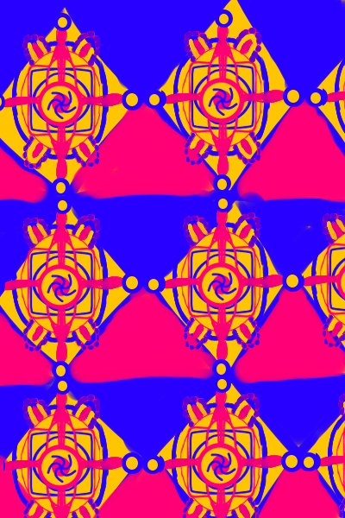

- How are you planning to incorporate randomization? Colors, position, shape types, movement, etc. Write out at least two ways you will be using randomness and include how random it will be. For example, if its color, will it be every color possible or only reds or only blues?
I will incorporate randomization by alternating background colors between blue and pink and randomizing the size of the spiral in the middle. I will also incorporate movement by having the rows of designs move. The top row will move left, and the bottom row will move right.

- What is the overall shape of your piece going to be? Square, portrait rectangle, landscape rectangle? Write your choice and why you have chosen it.
I am going to use a portrait rectangle with dimensions of 400 x 600. I think the tall portrait dimensions will make the side-to-side movements of the designs less visually jarring and will contribute to the psychedelic feel of the work.
- How will a new version of your pattern be chosen? Will it happen at regular intervals, on a mouse press, a keyboard press, or through animation? Describe how a new iteration will be generated.

I want to mimic the repetitive movement of a kaleidoscope, and I think that I will best achieve that effect by using random intervals. I think by having the pattern repeat itself every 3 seconds

- What do you hope will be the same across every iteration, and what will be different? In other words, what visual elements will be fixed and which will change. For example, if you will always have a grid of shapes, note that, or if you will always have circles but they might be in different places, note that.
I think the actual shape of the designs will stay the same, but the colors, size, and position will change consistently. For example, the order of the shapes and the image they create together will stay the same. I will also have the same range of risograph colors. So even when the colors change, they stay within the same range.

Description:
The artwork will have a background of triangles alternating between the colors blue and pink. On top of that, a combination of squares, ellipses, and circles will create a complex-looking shape. These shapes will move left in a consistent pattern at the top and right in a consistent pattern on the right. The work will include an aerial spiral in the middle made of rectangles. This spiral will be rotating consistently.

